
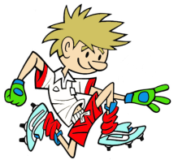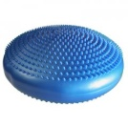

RULES – HOW TO PLAY

Players hold on to one end of rope or pole

Try to get your opponent from their mat/stability disc by pulling rope and unbalancing them

Each person starts with 5 points the person with most points at end of set time is winner

Every time you get pulled of mat you lose a point

Safety
Players may not use sudden jerks all pulls must be slow and only when partner is ready

FOCUS
To test coordination and strength while unbalanced

STATION 3: BALANCE
Activity: Tug of War
HARDER
- Make the mats smaller or stability discs softer
- Make players stand on one foot
- Use one hand only to pull partner off balance
- Use straight arm down along side for pulling (Good for building tummy muscles)
- Use 2 or 3 players to pull against each other

EASIER
- Bigger mat or hoop for children to stand in
- Use two hands to pull partner off-balance
- Rugby Push - Put hands on each others shoulders and push

-

EASIER -
-
-
COACHING POINTS

HEAD
- Head up facing opponent

HANDS
- Hands hold rope tightly, if using one hand keep other arm out to side for balance

FEET
- Keep 1 foot in front of the other and knees bent slightly
- Pull belly button into back bone to help engage core tummy muscles

EQUIPMENT

- Rope

- Small mat each

- Hoop (optional)

Copyright Ulster Council GAA 2009

